BALDIVIS SECONDARY COLLEGE
 Methods Units 1 and 2
2020 Test 1

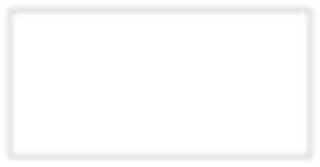
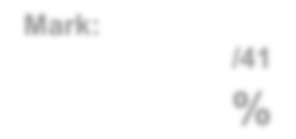
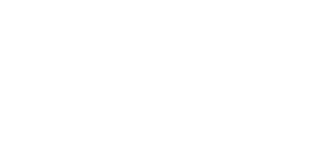
Mark:

/32

%

Student Name _____________________________________________

Time allowed for this task: 35 minutes, in-class, test conditions.
Section 1: 10 minutes
Section 2: 25 minutes

Materials required: Section 1 Calculator free section (10 marks)
Standard writing equipment
SCSA Formula Sheet

Section2 Calculator assumed section (22 marks)
Calculator (to be supplied by the student)
SCSA formula Sheet
One page A4 (double sided) hand written notes

Other materials allowed: Drawing templates

Marks available: 32 marks

Task Weighting: 2%

Question 1. [4 marks – 1, 1, 1, 1]
Use the diagram of a 20º angle on a unit circle provided to estimate the following values to two decimal places;

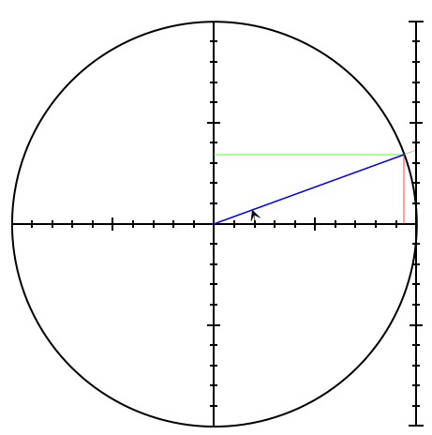

- cos 20º

- sin 20º

- sin 160º

- tan 160º

Question 2 [3 marks]

Complete the table using exact values:

Angle | Sin | Cos | Tan
150˚
300˚

Question 3 [3 marks]

The triangle shown below has an area of 36 cm², determine the value of x.

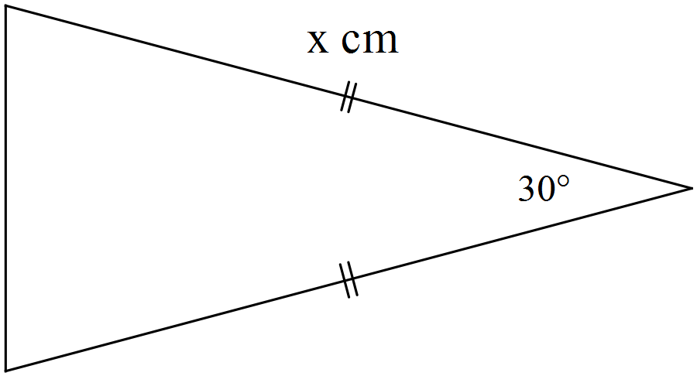

$$6cm$$

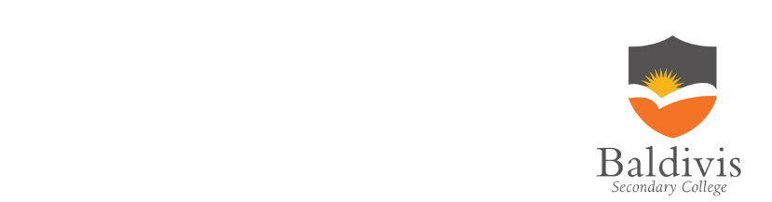

AEMAM Unit 1 – Test 1 – 2020

Name: Time allowed – 25 minutes

Calculator Assumed Section (1xA4 page of double sided notes and approved
calculators. Formula sheet provided.) – 22 marks

Question 4 [8 marks – 3, 2, 3]
- Show that the smallest angle in a 5 cm, 8 cm, 11 cm triangle is 24.6º.

- Hence, or otherwise, determine the area of the triangle.

- Use the Sine Rule to determine the size of the angle opposite the 8cm side.

Question 5 [6 marks]

Determine, correct to 2 decimal places, the length of side BD in the diagram below.
Note: Diagram not drawn to scale.
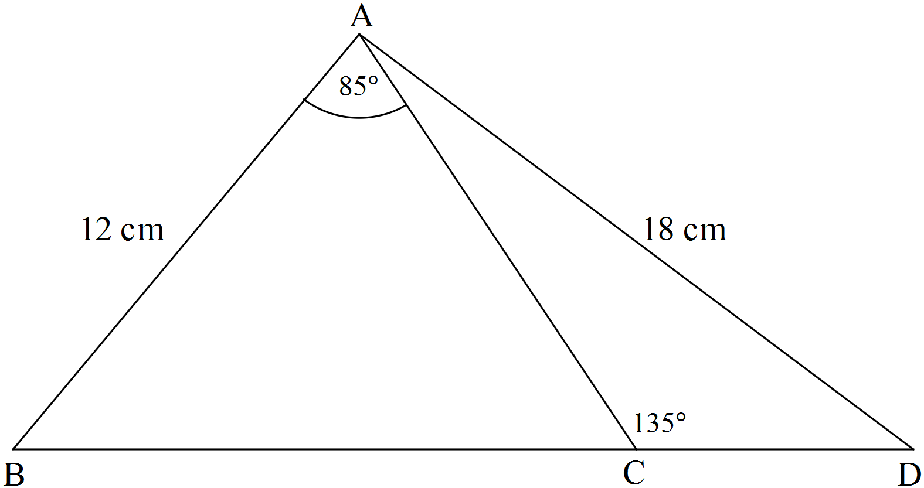

Question 6 [8 marks]

In triangle ABC, A = 30º, a = 5 and c = 7.

Find the difference in the two possible areas for ∆ABC.
Hint: Draw a labelled diagram

END OF ASSESSMENT

